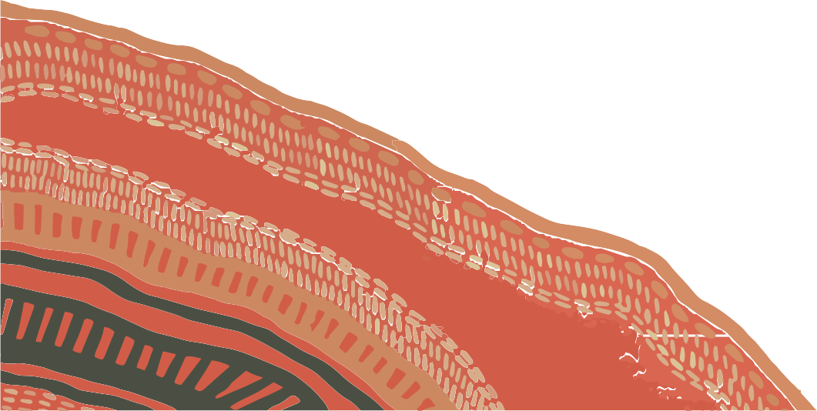
CRICOS Provider 00109J | Last Monday 26/06/2023 | IF A4 - Callaghan

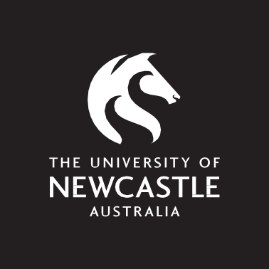
ACKNOWLEDGEMENT OF COUNTRY

CALLAGHAN SPECIFIC
I would like to start by acknowledging that we are on the traditional lands of the Pambalong clan of the Awabakal nation.
I acknowledge and pay my respect to the Elders past, present and emerging.
I would like to extend this acknowledgement and pay my respects to Aboriginal and/or Torres Strait Islander peoples here today.
I recognise that First Nations sovereignty was never ceded. This continent always was and always will be Aboriginal Land.

Artwork:
Wun.ngul Yayan Mudyala (Yesterday, Today, Tomorrow) by Artist Frances Belle-Parker.
This document was produced by the University Library.

